
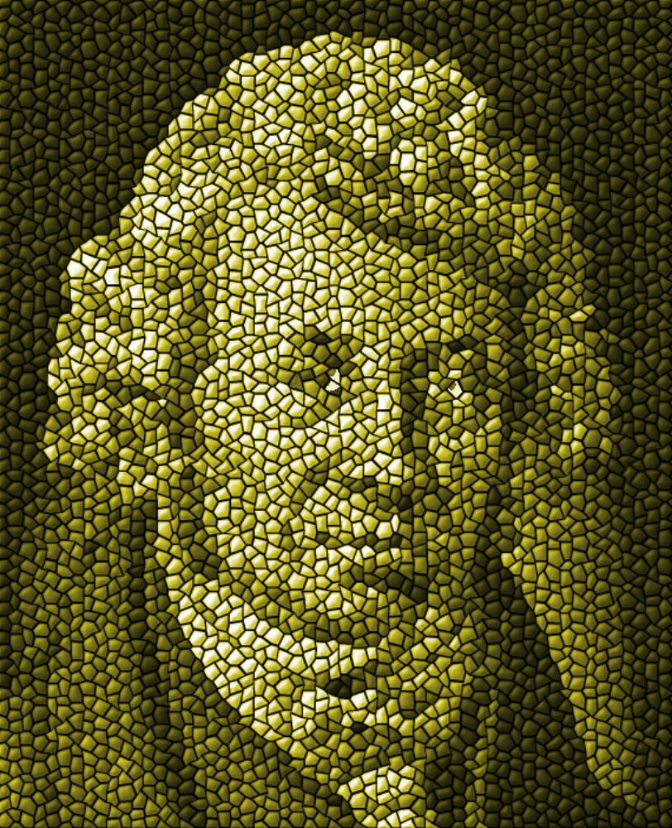
A

ndré-Marie Ampèr
E

“Believe in God, in His providence, in a future life...in the … truth of the doctrines of Christ … for the salvation of the human race.”

Ampère's Law. The "amp"
is the MKS unit of electrical current. Ampère's name is one of the 72 names inscribed on the Eiffel Tower.
“Believe in God, in His providence, in a future life...in the … truth of the doctrines of Christ … for the salvation of the human race.”

